Roll No: __________________

Amrita Vishwa Vidyapeetham

B.Tech. First Assessment - August -2017

Fifth Semester

Computer Science and Engineering

**15CSE337 Cloud Computing and Services**

**Answer all the questions**

1. Describe the different deployment models in cloud computing with a real time scenario. (5 Marks)
2. Answer the following questions. (8 Marks)
   1. What is virtualization? Explain virtualization with a neat diagram.
   2. State the differences between para and full virtualization?
3. Draw the Amazon Architecture and explain the same. (7 Marks)
4. Design a page which contains only your Emp ID (eg. Your Roll Number)

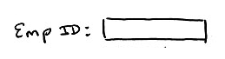 

It emp Id matches your roll number then, the system should navigates to the second page shown below or else an error page.

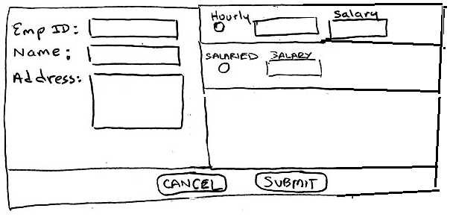

In page 2, user submits the form, all the details to be stored in Amazon S3 and the same can be view after the successful submission. If the employee is hourly basics, the salary should be number of hours * salary else (Salaried) the salary should be salary * 30.

* 1. The emp ID entered in the page one should automatically populated into the page two emp id field. (5 Marks)
  2. Store all the details from page two in the local machine (ie.., your system) as “emp.txt”. (10 Marks)
  3. The emp.txt should be stored in Amazon S3. ( 8 Marks)
  4. Data retrieved from S3 and to be displayed in the web page. ( 7 Marks)